2018-2019



A non-profit organisation of engaged parent volunteers.

Europawijk 100
B-2400 MOL
www.paesmol.eu

CONTACT INFORMATION

Office Manager: Marie Rose Poesen
Tel: +32 (0) 14 56 31 53
Email: pa@esmol.be

The PA office is located in the Primary building: please drive to the back of the primary building, take the daycare entrance, the 1st room when entering the building at the back.

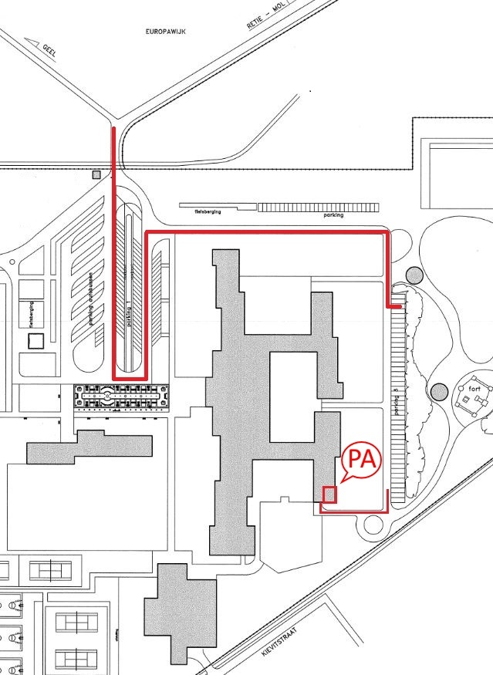

OPENING HOURS:
Monday and Tuesday from 08.00 -12.00 and 12.30 – 16.30
Wednesday: 08.00 – 12.30
Thursday: 08.00 – 11.30

Bank information:
IBAN: BE48 3630 7005 2127
BIC: BBRUBEBB

TABLE OF CONTENTS

- Presentation of the Parents Association p. 4

- Your voice at school p. 5

- Putting your children first: our services p. 6
Daily buses p. 6
After-school care and activities p. 7

- Other activities organised by the PA p. 8
Welcome Committee
Events

- Practical information about our school p. 9
Important contacts
School hours
Canteen
Host families
School premises

1. Presentation

At the European School of Mol, the Parents’ Association (PA) plays a key role in providing a variety of services for the children as well as representing the interests of your children. We are the interface between the parents, the school management, the various school committees and the Board of Governors (which manages all European schools). We aim to provide parents with information and support and we meet regularly to discuss ongoing school issues.

Membership
Membership of the PA is voluntary and open to all parents whose children attend the school. It only costs 30 euros per school year and per family.
Please note that the families whose children use the PA’s services must be enrolled as members. This membership fee will be included in the first daycare or transport invoice.

Why join the PA?
As a member you can:
- vote at PA General Meetings and elect the board.
- enjoy all the PA benefits such as after-school care and transport.
- participate in the PA workgroups. Through these workgroups, every parent can influence and improve the school community.
We look forward to your membership and hope to welcome you in one of our workgroups!

How to contact us
The best way to reach us is by email at pa@esmol.be
English is the main working language in the Parents Association meetings and internal communications, but feel free to contact us also in Dutch, French & German.
Please make sure that you give the school your e-mail address when registering, and give permission to share your contact details with the PA.
All information and invoices are sent by email. Please make sure the PA always has your latest email address.

2. Your voice at school
Parent Representation
The PA is the link between children/parents and the school management.
Class Representatives (a parent who is elected to represent a given class) are the first level of parents’ representation in our school. They play an important role in the communication between the parents and the PA, as all Class Reps are invited to 2 to 3 meetings per year with the PA & the school management.

Class Reps typically support the teacher where needed, give information to all class parents and bring class issues to the PA. They listen to different opinions, are aware of cultural differences and aim to support all the parents in their class.

The PA also participates in different committees & working groups, such as:
School Administration Board
This board supervises the effective management & administration of the school and budgets, and meets twice a year.
Education Councils
In Nursery, Primary and Secondary, these meetings take place three times a year between teachers, parents and the school management to discuss school-related issues. Optimal conditions for effective teaching are discussed and positive and stimulating relationships between all parties are enhanced.
Health & Safety Committee
This committee focuses on issues such as safety on the school premises prevention/information and meets with the school management 2 to 3 times a year.
The PA sponsors fruit for every student on a weekly basis.
Currently this is only for the secondary pupils.

Canteen Committee
The PA, together with pupils, teachers and the chef get together to review issues and suggestions for a continuous improvement of the canteen service.
Interparents
Interparents is the umbrella organisation of all Parents Associations of the 14 European Schools. Its main purpose is to represent the parents of all European Schools pupils in the Board of Governors, its Committees and Working Groups. Interparents also facilitate exchange of information and cooperation among the member associations.

3. Putting your child first: our services
At the PA, we always put your child first, supplying several services. As a member of the PA, you can benefit from all the services listed below.
The yearly membership is 30 euros per family.

Daily buses
Every day, the PA school buses bring children from Antwerp and Eindhoven. We currently operate 3 different buses from the Antwerp area and 1 bus from Eindhoven.

Each bus follows a different timetable. More information about itinerary, stops and times is available on our website: http://www.paesmol.eu/services/transport

To apply for transport, please fill in the registration form online. After the online registration is closed, registration is only possible in the PA office.
Please note that registration of your child at the European School does not automatically include transport, parents must apply separately for PA bus subscription. The PA relies on the parents for the smooth operation of this service. Children must be at the stop on time (at least 5 minutes prior to the bus arrival) and they are responsible for their children’s behaviour during the journey.
Transport from other cities is also possible if there are enough requests to make it financially viable. Please let us know if you are interested in a specific stop/route that isn’t currently covered.

After-School Care Centre and Activities
The PA organizes and runs the After-School Care Centre on campus. The After-School Care is open every school day. More detailed information about registration, fees and activities can be found on our website: http://www.paesmol.eu/services/daycare
http://www.paesmol.eu/activities
email: daycare@esmol.be

The After-School Care is intended for nursery & primary school pupils and - in exceptional cases - secondary school pupils.

- Registration

Registration for the after-school care is done online. You will be informed of the start and closure of the registration. In January this registration procedure is repeated to enable changes in the chosen activities.

- Facilities & Staff

The after-school care team consists of two experienced day care teachers and is supported by a group of highly motivated volunteers. The dedicated work and skills of this team assures the well-being of the children. Three playrooms are fully equipped with a variety of toys, games and equipment for each age group, to insure that children feel at home in our centre. They can do their homework, play together in groups and express their own creativity in art areas. They can also have fun outside on the playground, weather permitting.

- Activities

During after-school care hours, children can also participate in various optional activities requiring an additional fee on top of the regular day care fee. Current activities include: Arts & Crafts, Ballet, Kids Gymnastics, Multi Sports, Piano, Dutch, Dance, Football, Cooking and Singing. These activities are coached by certified instructors on Mondays and Fridays. If you would like to suggest any other activity, please feel free to contact us.

- Safety rules

When registering your child for after-school care, you will have to fill out a form specifying the names of the adult(s) authorised to pick up your child. If, due to circumstances, one of the 2 listed adults are not able to pick up your child, notify the person responsible at the day care A.S.A.P via mail: daycare@esmol.be or telephone:

+32 (0)14 56 31 16 or +32 (0)488 106 855

  - You can pick up your child entering the after school care centre via the main door of the day care (behind the Primary School building).
Go to the information desk, show your ID card to the volunteer and mention the name of your child.

4. Other PA activities

Welcome Committee
Are you new to our school or to the area? We all know what it is like to relocate to a new country or area and would like to make the transition as smooth as possible for you and your family. The Welcome Committee is here to help you become better acquainted with your new surroundings. It is made up of several parents of the school who will be available to answer your questions and offer advice about school life, the local area and Belgian customs.

Events
Coffee mornings
The PA organises several coffee mornings a year, which are an excellent way to meet other parents, as well as members of the PA and the school management. It is a good opportunity to network and make new friends, especially if you are new at our school.
These coffee mornings are always held in the canteen starting at 8.30 a.m., and take place on the first and last school days, and throughout the year. Don't miss them!

Newcomers’ Afternoon
To welcome new parents to our school and give a good first information session, the PA organises an informational evening for new parents together with school management on the evening before the 1st school day.

St Martin’s Day
In November, Nursery and Primary school children can expect an evening of bonfire, hot beverages and snacks.

Open Day
On the Open Day, the PA hosts an International Food Market, where parents and children can enjoy food from many different countries and participate in several entertaining activities.

End-of-Year Picnic
In June, the PA organises an afternoon of fun, games, music and snack food for our entire school community. Families of parents & staff bring along their picnic and enjoy a fun summer day!

5. Practical information about our school

The European School of Mol is an intergovernmental school. Established in 1960 to provide education to children of employees of the European institutions, pupils nowadays come from Europe and beyond, with currently more than 50 nationalities united at the school.

Educating for ages 3 – 18 the school offers a nursery, primary and secondary cycle to all children. From the age of 3, all children receive tuition in the language of their section (English, Dutch, French or German) and at the age of 6 second language tuition starts. By the end of their secondary studies, pupils will have had the opportunity to study up to five languages, mainly taught by native speakers.
Pupils successfully completing the European Baccalaureate at the end of the seventh year of secondary education receive this certificate. Thanks to high academic standards and an individualized approach, more than 97% of all pupils pass this examination. The European Baccalaureate is acknowledged by all EU member states and most universities worldwide, guaranteeing pupils the right of access at any European university or higher education.
For more information, please visit the school website: www.esmol.be

Important contacts

- Management:
Tel. +32(0)14/56.31.01, dir@esmol.be
- Primary school:
Tel. +32(0)14/56.31.80, Fax +32(0)14/56.31.83, prim@esmol.be
- Secondary school:
Tel. + 32(0)14/56.31.03, Fax +32(0)14/56.31.41, sec@esmol.be
- Pedagodical advisor:
Tel +32(0)14/56.31.03, Fax +32(0)14/56.31.41, ped@esmol.be
- Accounting department:
Tel. +32(0)14/56.31.91, Fax +32(0)14/56.31.96, admfin@esmol.be
- Medical service:
Tel. +32(0)14/56.31.40, Fax +32(0)14/56.31.83.
- Canteen:
Tel. +32(0)14/56.31.60, can@esmol.be
- Webmaster : webmaster@esmol.be

School hours
Nursery (children aged 3 to 6)
Monday: 08:30 – 13:30
Tuesday & Thursday: 08:30 – 16:15
Wednesday & Friday: 08:30 – 12:30
Primary school (children aged 6 to 11)
-Years 1 & 2
Monday: 08:30 – 13:30
Tuesday & Thursday: 08:30 – 16:15
Wednesday & Friday: 08:30 – 12:30
-Years 3, 4 & 5
Monday, Tuesday & Thursday: 08:30 – 16:15
Wednesday & Friday: 08:30 – 12:30
Secondary school (pupils aged 11 to 18)
Monday, Tuesday, Thursday & Friday: 08:30 – 12:50 & 13:45 – 16:15
Wednesday: 08:25 – 12:35

Canteen information
Meals for nursery pupils are served at nursery school. All other children use the self-service system in the canteen. Every day, there are sandwiches, soup, a main course, salads, vegetables, dessert or fruit. There is also a vegetarian dish available. Water is provided.
The weekly menu is posted on the school website: www.esmol.be.
Children who bring their own lunch can also eat in the canteen.

- Registration & tickets information

Our canteen is managed by Scolarest since September 2014. Pupils must register first to use the canteen service: meals must be prepaid and the pupils use their canteen card. A full meal costs € 5,41 and sandwiches
€ 3,18. Parents or visitors are also welcome to use the canteen of our school.

- Snacks and drinks

Drinks, coffee, tea, soup, milk, chocolate milk, and various snacks can be bought in the canteen.

Boarding facilities and host families

Some parents live far from Mol or even abroad; in such cases their children usually stay during the week in the boarding facility “De Immert” nearby Leopoldsburg (www.immert.be). Some children prefer to stay with a host family near our school. This way they get to experience the warmth of a family during their stay here.
If parents need help regarding finding a host family or carpooling, the PA will try to help.

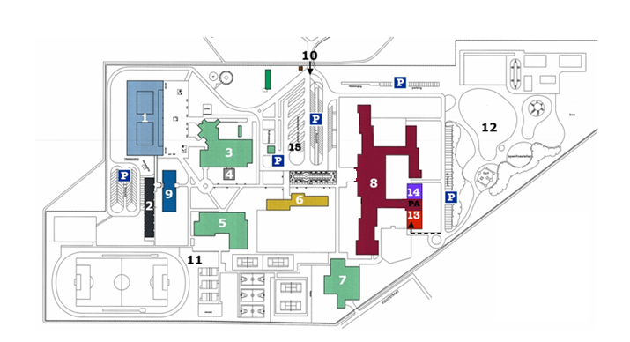

SCHOOL PREMISES:

1. Secondary school
2. Domus
3. Canteen
4. Pergola canteen
5. Gymnasium
6. Nursery school
7. Swimming Pool
8. Primary school
9. Administration
10. Entrance
11. Sport fields
12. Primary playground
13. PA Office
14. IRMM Creche
15. Bus parking

PARENTS’ ASSOCIATION
EUROPEAN SCHOOL MOL



Tel: +32 (0) 14 56 31 53
Email: pa@esmol.be

OFFICE OPENING HOURS:
Monday – Tuesday: 8:00 – 12:00 & 12:30 – 16:30
Wednesday: 8:00 – 12:30
Thursday: 8:00 – 11:30

Printed: July 2018

